**1.Display the customer names that share the same address.**

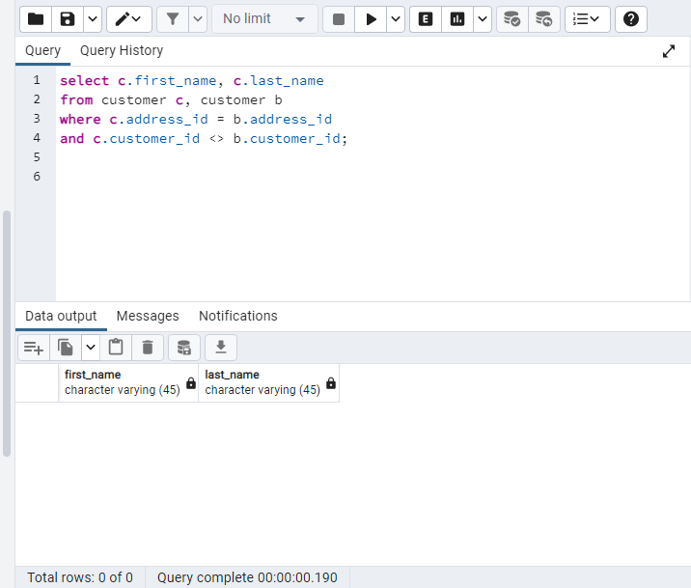

**2. What is the name of the customer that has the highest total payment?**

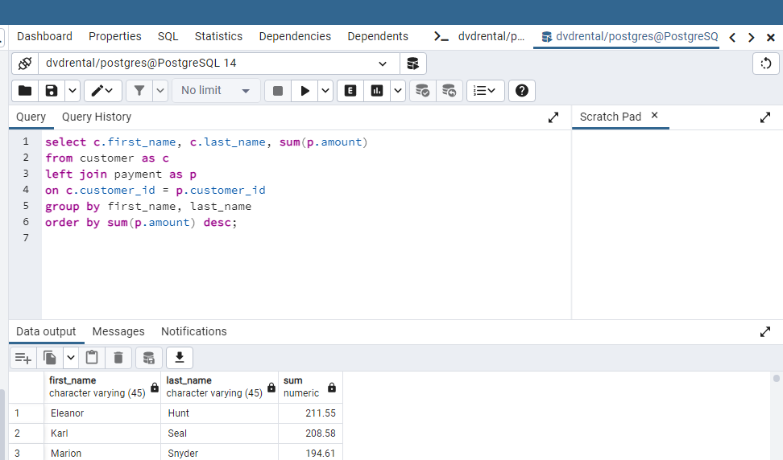

**3. What is the movie that was rented the most?**

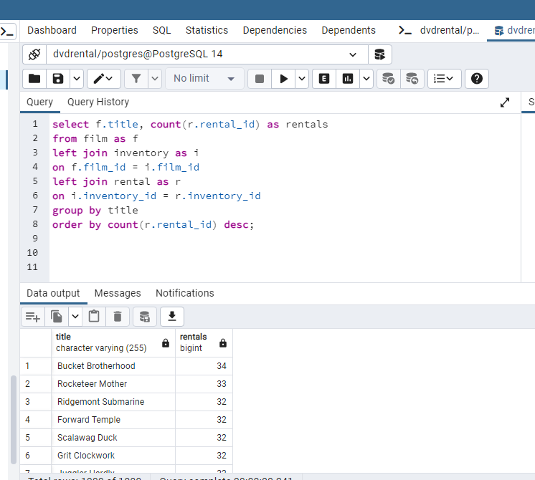

**4. Which movies have been rented so far?**

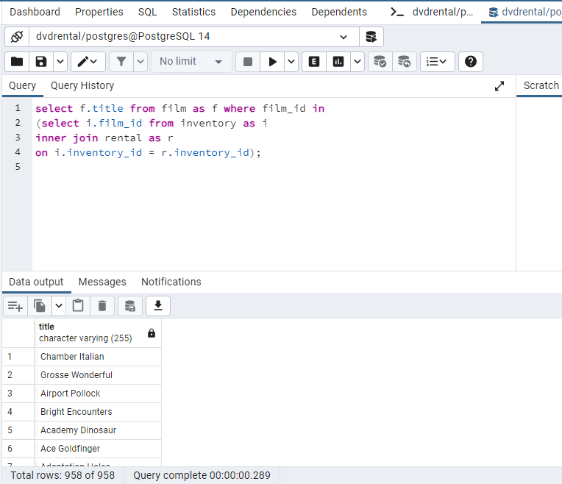

**5. Which movies have not been rented so far?**

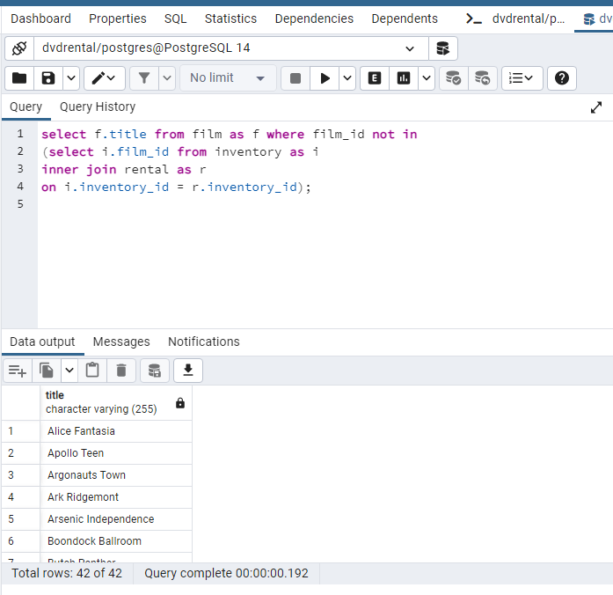

**6. Which customers have not rented any movies so far?**

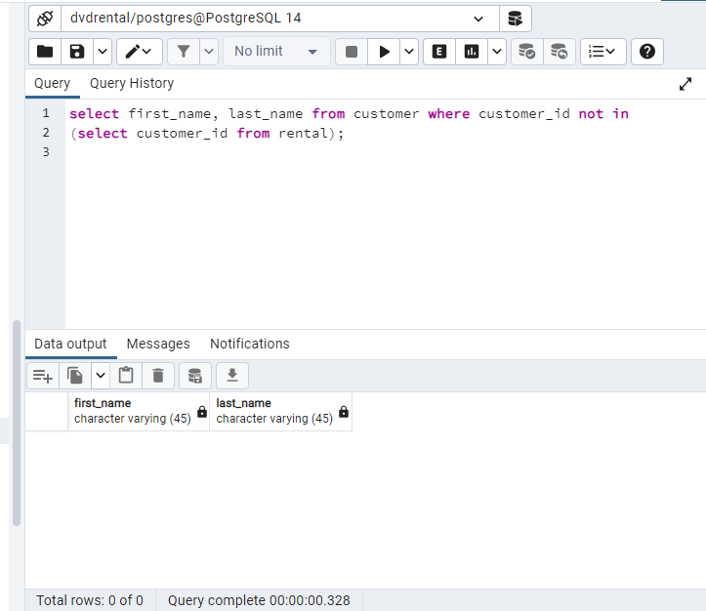

**7. Display each movie and the number of times it got rented**.

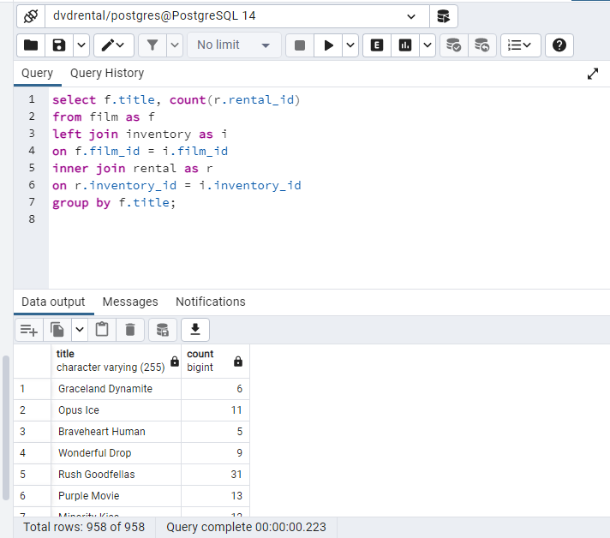

**8. Show the first and last names and number of movies each actor has acted in.**

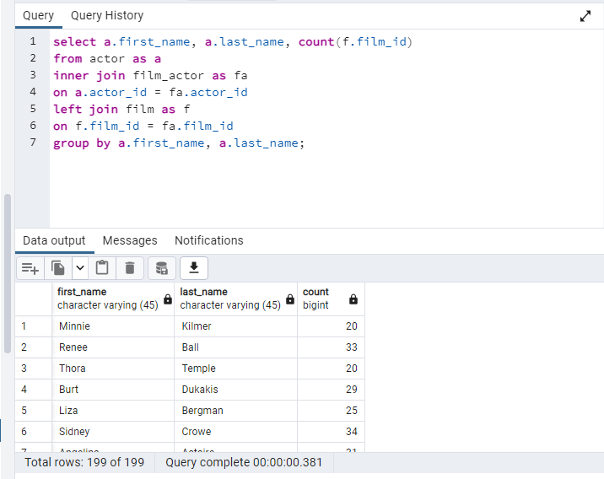

**9. Display the names of actors that acted in more than 20 movies.**

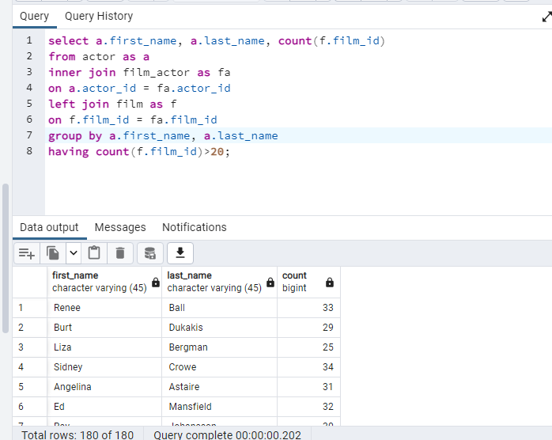

**10. For all the movies rated ‘PG’, show the movies and the number of times it got rented.**

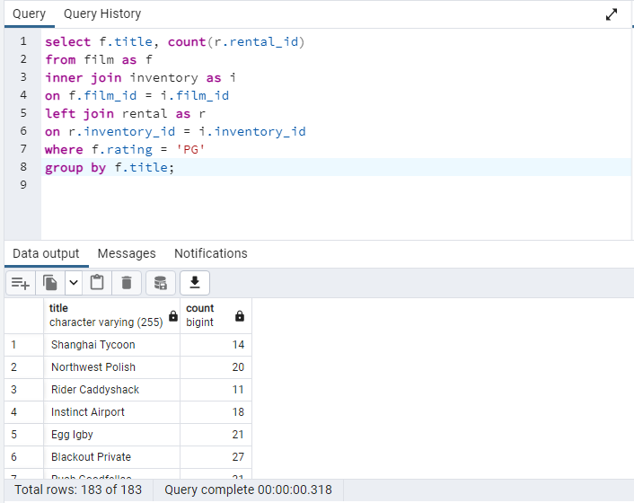

**11. Display the movies offered for rent in store_id1 and not in store_id2.**

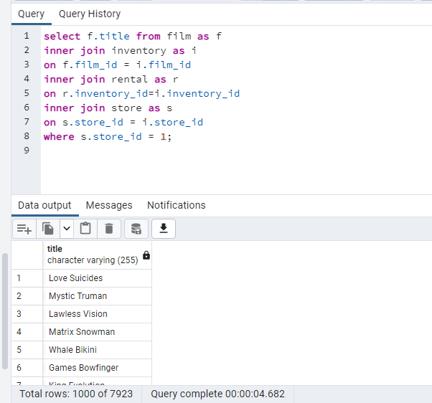

**12. Display the movies offered for rent in any of the 2 stores**

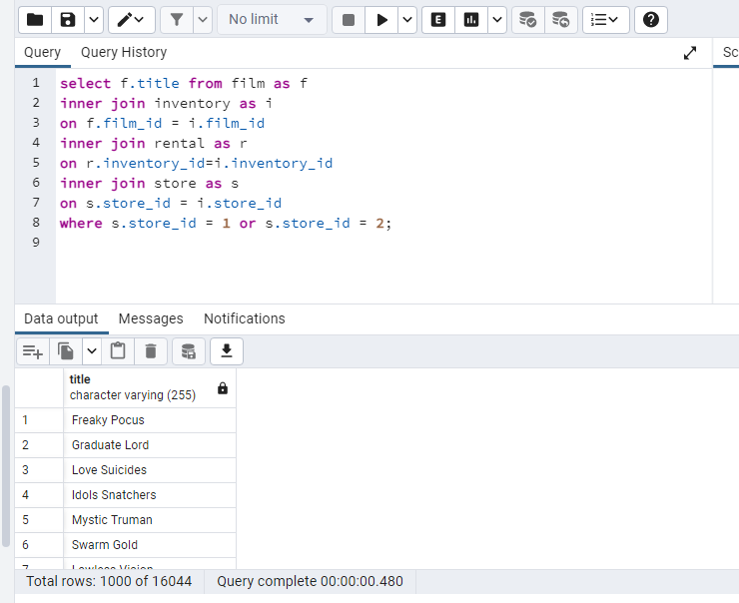

**13. Display the movie titles of movies offered for rent in both stores at the same time**

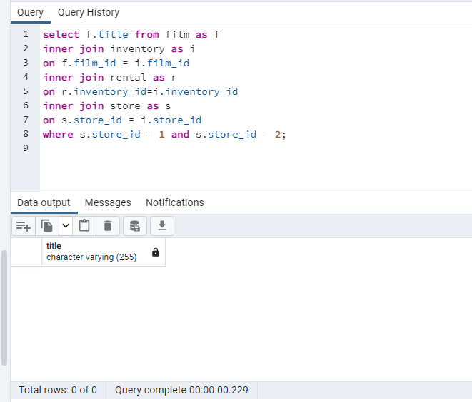

**14. Display the movie title of the most rented movie in the store with store_id1**

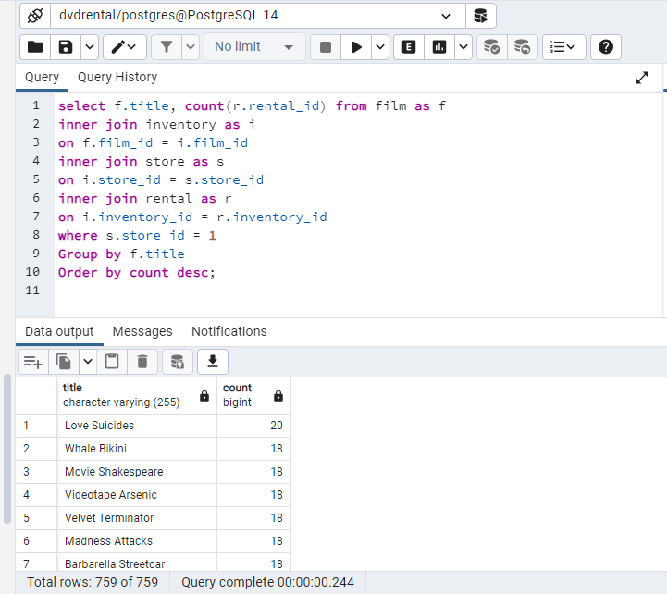

**15. How many movies are not offered for rent in the stores yet?**

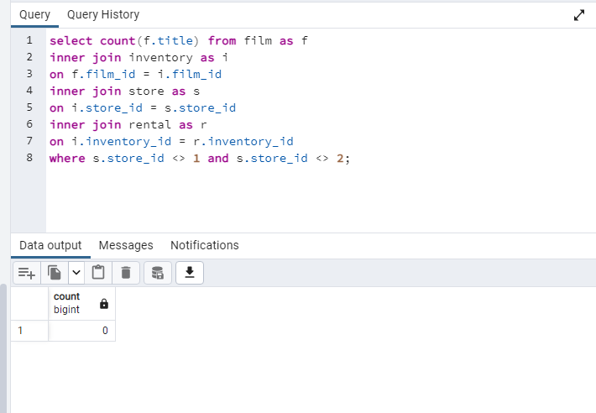

**16. Show the number of rented movies with each rating**

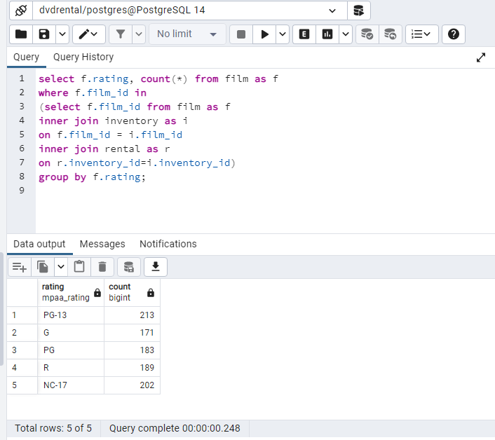

**17. Show the profit of each of the stores 1 & 2**

